PROJECT REPORT
Student Management System
A Complete CRUD-Based Web Application
Submitted in accordance with the SOP for
Complete CRUD-Based Web Application Development
Student Name | Aazhiga N
Roll No. / ID | 922525106002
Course / Batch | ELECTRONICS AND COMMUNICATION ENGINEERING
Section | A
Date of Submission | 17/09/2026
Repository Link

1. Project Title and Overview
Project Title: Student Management System
Category: Web-based CRUD Management Application
The Student Management System is a full-stack web application that allows an institution to maintain digital records of its students. It implements all four Create, Read, Update and Delete (CRUD) operations through a REST API, backed by a relational database, and exposed through a browser-based user interface. The system was built following the project SOP for CRUD-based web application development, covering requirement analysis, database design, backend API development, frontend development, frontend-backend integration, validation, and testing.
Frontend: HTML, CSS, vanilla JavaScript (fetch API)
Backend: Django 5 with Django REST Framework (DRF)
Database: SQLite (development database, file-based)
API Testing: Postman collection (8 pre-built requests)
Version Control: Git / GitHub (README documents setup and usage)

2. Problem Statement
Educational institutions and training centres need a simple, reliable way to record and maintain core student information — name, contact details, department, year of study, and academic performance (CGPA) — without depending on spreadsheets or paper registers, which are error-prone, hard to search, and do not enforce data consistency. The application addresses this by providing a single-entity (Student) management system where records can be added, listed, searched, filtered, edited, and removed through both a REST API and a user-friendly web interface, with validation enforced on both the client and the server to keep the stored data accurate and consistent.

3. Objectives
- Design a normalized data model for storing student records with appropriate constraints.
- Build a RESTful backend using Django REST Framework that exposes full CRUD endpoints for the Student resource.
- Implement both client-side and server-side validation, including duplicate-email protection and format checks.
- Develop a responsive HTML/CSS/JavaScript frontend that consumes the REST API using the Fetch API.
- Provide search-by-keyword and filter-by-department functionality on top of the list endpoint.
- Enable administrative access to the data through Django's built-in admin interface.
- Verify the API independently using a documented Postman collection covering success and failure cases.
- Document setup, execution, and API usage so the project can be reproduced from source.

4. Technology Stack
Layer | Technology Used | Purpose
Frontend | HTML5, CSS3, JavaScript (ES6, Fetch API) | Renders the student list/table, the add/edit form, and communicates with the API
Backend | Django 5.x + Django REST Framework 3.15 | Application server, ORM models, and REST endpoints
Database | SQLite (db.sqlite3) | Persistent storage for student records, created via Django migrations
Admin Console | Django Admin | Administrative CRUD view with search and filter for staff use
API Testing | Postman collection (StudentManagement.postman_collection.json) | Manual and repeatable testing of every endpoint
Version Control | Git / GitHub | Source code management (per README instructions)

5. System Architecture
The application follows the standard 3-tier architecture recommended in the SOP: a browser-based frontend, a Django REST Framework backend exposing a REST API, and a SQLite database accessed through Django's ORM.
User → HTML/CSS/JavaScript Frontend (served by Django templates/static files) → REST API (/api/students/) → Django REST Framework Views → Django ORM → SQLite Database
Because the frontend is served directly by Django (via the students/templates and students/static folders) rather than as a separately hosted React app, the frontend and backend share the same origin, so no CORS configuration was required for this deployment. The project remains organized as two Django apps: student_management (project configuration, URLs, settings) and students (the Student model, serializer, views, URLs, admin, templates and static files), which keeps concerns separated as required by the SOP.

6. Database Design
A single entity, Student, models all data captured by the system. It is defined in students/models.py and maps to one SQLite table created via Django migrations.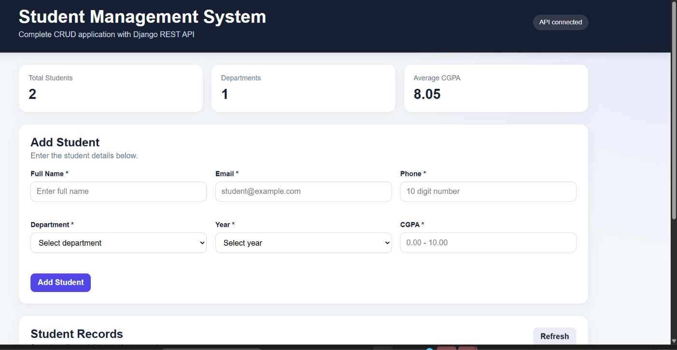
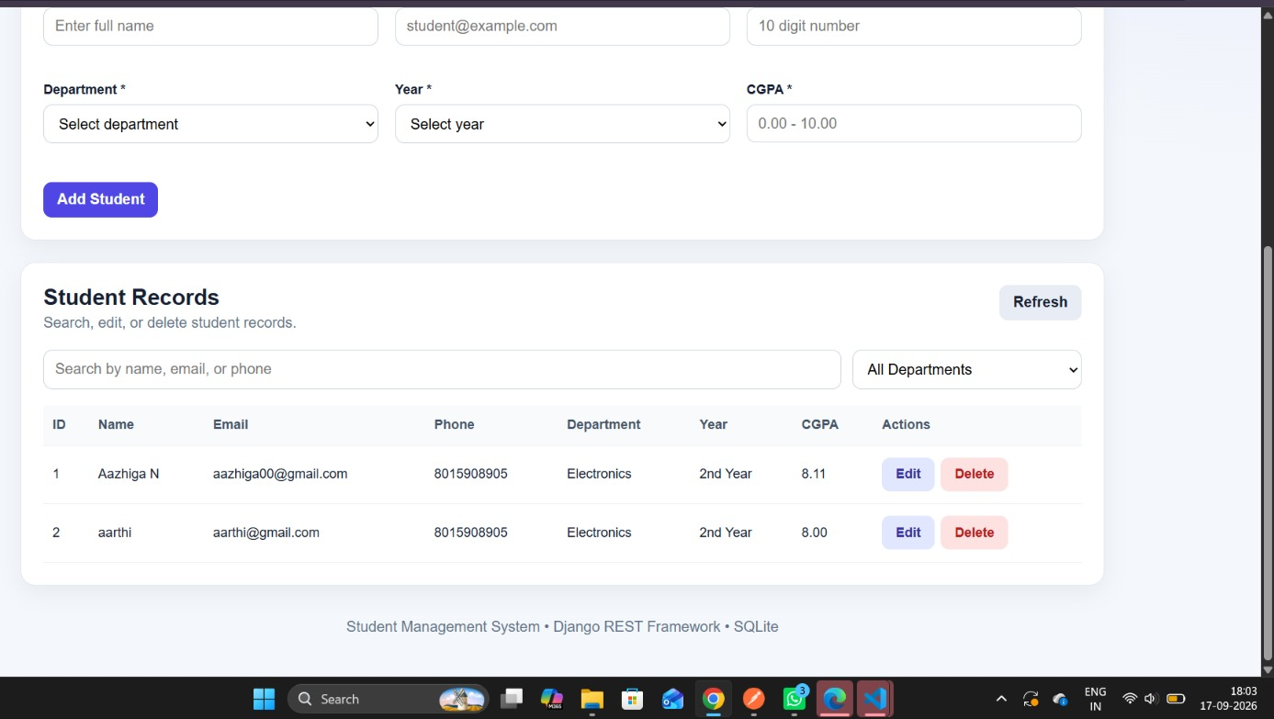

6.1 Student Table Schema
Field | Type | Constraints
id | AutoField (PK) | Primary key, auto-incrementing
name | CharField(100) | Required
email | EmailField(254) | Required, unique, valid email format
phone | CharField(10) | Required, must be exactly 10 digits (regex validated)
department | CharField(50, choices) | Required, one of 7 predefined departments
year | PositiveSmallIntegerField (choices 1–4) | Required, min 1 / max 4
cgpa | DecimalField(4,2) | Required, min 0.00 / max 10.00
created_at | DateTimeField | Auto-set on creation (auto_now_add)
updated_at | DateTimeField | Auto-updated on every save (auto_now)
The email field carries a database-level UNIQUE constraint, satisfying the SOP requirement that duplicate unique values be handled correctly. Records are ordered by id (Meta.ordering), and the department field uses a fixed set of choices (Computer Science, Information Technology, Electronics, Electrical, Mechanical, Civil, Other) to keep the data consistent for filtering.

6.2 Entity Relationship Summary
The current scope has a single entity with no foreign-key relationships. This matches a Student Management System used as a standalone register; the Future Enhancements section proposes related entities (Courses, Enrollments) that would introduce relationships in a later iteration.

7. Backend Development
The backend is implemented with Django REST Framework generic class-based views, which keep the CRUD logic concise while still allowing custom query-parameter handling for search and filtering.

7.1 REST API Endpoints
Operation | HTTP Method | Endpoint | View
Create | POST | /api/students/ | StudentListCreateView
Read All | GET | /api/students/ | StudentListCreateView (supports ?search= and ?department=)
Read One | GET | /api/students/{id}/ | StudentDetailView
Update | PUT | /api/students/{id}/ | StudentDetailView
Partial Update | PATCH | /api/students/{id}/ | StudentDetailView
Delete | DELETE | /api/students/{id}/ | StudentDetailView

7.2 Search and Filter
The list endpoint accepts two optional query parameters: search, which performs a case-insensitive partial match across name, email, and phone; and department, which restricts results to an exact department value. Both can be combined, and .distinct() is applied so that a record matching more than one search condition is not returned twice.

7.3 Serialization and Server-Side Validation
StudentSerializer (a DRF ModelSerializer) exposes all model fields and marks id, created_at and updated_at as read-only. It adds explicit field-level validators beyond the model constraints:
- validate_name — rejects empty or whitespace-only names and requires at least 2 characters.
- validate_phone — rejects any value that is not exactly 10 digits.
- validate_cgpa — rejects values outside the 0–10 range.
Because these checks run at the serializer layer in addition to the model-level validators (RegexValidator for phone, MinValueValidator/MaxValueValidator for year and cgpa, unique=True for email), the API enforces validation even when a request bypasses the browser form entirely — satisfying the SOP requirement that server-side validation exist independent of client-side checks.

7.4 Django Admin
students/admin.py registers the Student model with list_display, search_fields (name, email, phone) and list_filter (department, year), giving staff a ready-made administrative CRUD interface at /admin/ in addition to the custom frontend.

8. Frontend Development
The frontend is a single page (students/templates/students/index.html) styled with students/static/students/style.css and driven by students/static/students/app.js (approximately 290 lines). It is served directly by the home view in students/views.py.

8.1 Key UI Elements
- A header with a live API-status indicator ("API connected" / "API unavailable").
- Summary stat cards: Total Students, Departments, Average CGPA — recalculated on every data refresh.
- An Add/Edit form (studentForm) with fields for name, email, phone, department, year and CGPA, each with an inline error placeholder.
- A results table listing every student with Edit and Delete action buttons per row.
- A search box (debounced, 250 ms) and a department dropdown filter, both re-querying the API automatically.

8.2 Client-Side Behaviour
app.js uses the Fetch API to call the /api/students/ endpoints for every operation. Loading a list of students, submitting the form (create or update, based on whether editingId is set), clicking Edit (which populates the form and switches it to edit mode), and clicking Delete (with a confirmation step) all trigger a request followed by a re-render of the table and stat cards, so the UI always reflects the current server state. Output values are passed through an escapeHtml helper before being written to the DOM, which is good practice against markup injection from stored data. Client-side field validation mirrors the server rules (required fields, phone digit format, CGPA range) so users see immediate feedback before a request is even sent.

9. Frontend–Backend Integration
- The frontend and backend are integrated using the Fetch API, exchanging JSON payloads.
- Because the page is served by Django itself, both share the same origin, so no cross-origin (CORS) configuration was necessary for this deployment.
- After every Create, Update or Delete action, the table and stat cards are refreshed automatically from the server.
- Network or server errors are caught and surfaced to the user as a message banner, and the API-status indicator switches to "API unavailable", satisfying the SOP's error-handling test case (backend/database unavailable).

10. CRUD Functional Requirements
Function | User Action | System Behaviour Observed
Create | Fill the form with valid data and submit | POST request creates the record; table and stats refresh; success message shown
Read | Open the page / use search or department filter | GET request lists matching records; empty state shown when none match
Update | Click Edit, modify fields, save | Form switches to edit mode (Cancel Edit appears); PUT request updates the record
Delete | Click Delete and confirm | DELETE request removes the record; table and stats refresh

11. Validation Implementation
SOP Requirement | How it is Implemented
Mandatory fields must not accept empty values | Client-side required checks in app.js; validate_name in the serializer; blank=False by default on model CharFields
Email must follow a valid format | Django EmailField validation at the model and serializer level
Numeric fields must accept only appropriate ranges | MinValueValidator/MaxValueValidator on year (1–4) and cgpa (0–10), enforced again in validate_cgpa
Duplicate unique values handled correctly | email has unique=True at the database level; DRF returns a 400 error with a clear message on conflict
Server-side validation even with client-side validation present | All rules are re-checked in StudentSerializer regardless of what the browser already validated
Validation errors clearly communicated | DRF returns field-keyed JSON error messages; app.js maps these into the inline error placeholders and the message banner

12. Testing Procedure
API testing was carried out with the bundled Postman collection (postman/StudentManagement.postman_collection.json), which uses a {{base_url}} variable defaulting to http://127.0.0.1:8000 so it can be pointed at any environment without editing individual requests.

12.1 Postman Test Cases
# | Request | Purpose
1 | Get All Students | Verifies the Read (list) endpoint, including behaviour on an empty database
2 | Create Student | Verifies the Create endpoint with valid data
3 | Get One Student | Verifies the Read (detail) endpoint for a valid ID
4 | Update Student | Verifies full update (PUT) of an existing record
5 | Partial Update CGPA | Verifies partial update (PATCH) of a single field
6 | Delete Student | Verifies the Delete endpoint removes the record
7 | Validation - Invalid Email | Confirms invalid/duplicate email input is rejected with a clear error
8 | Invalid ID | Confirms a request against a non-existent ID returns an appropriate error response

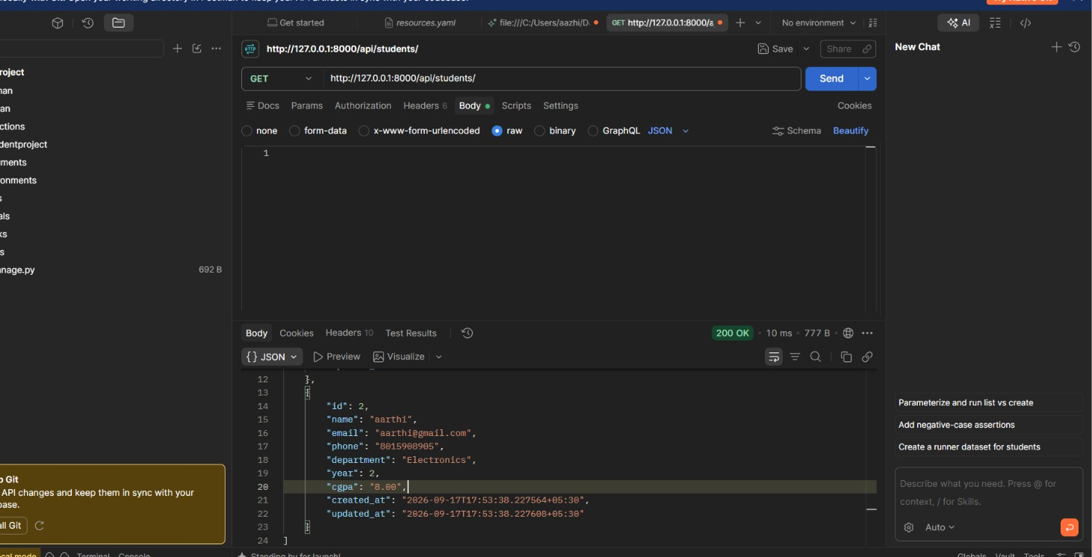
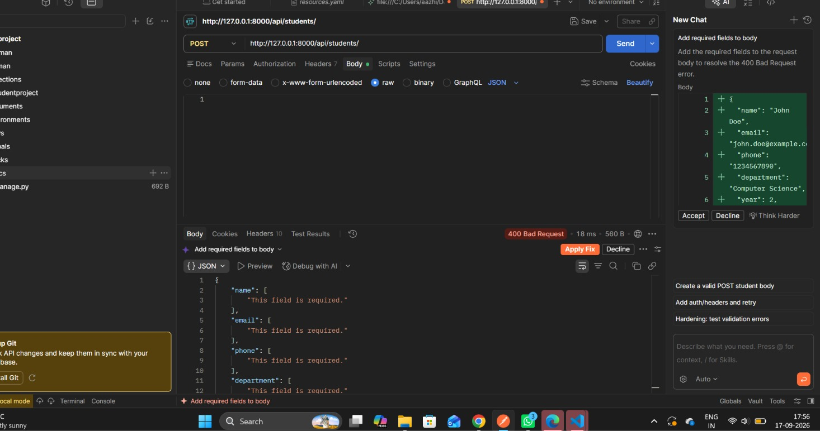
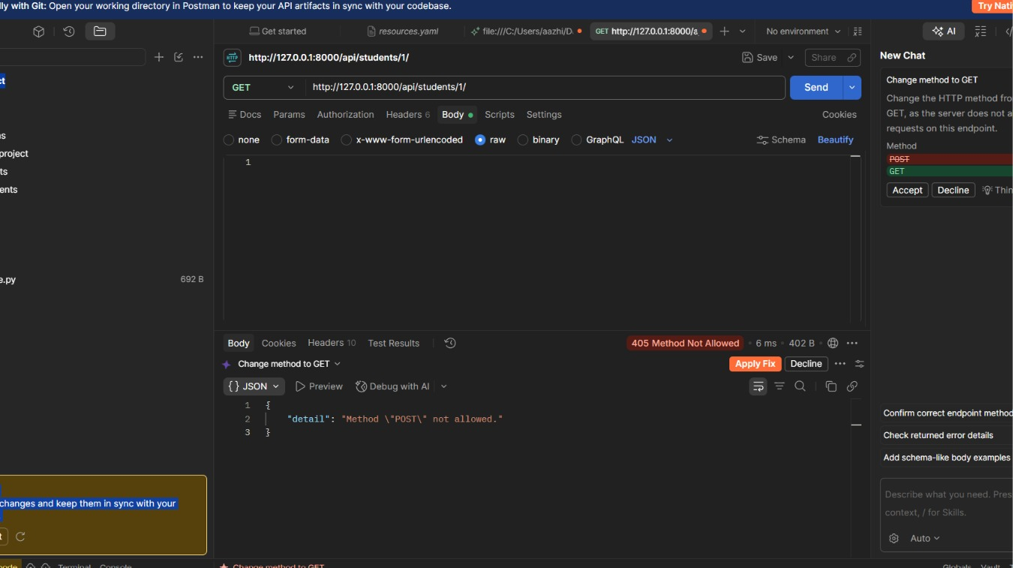
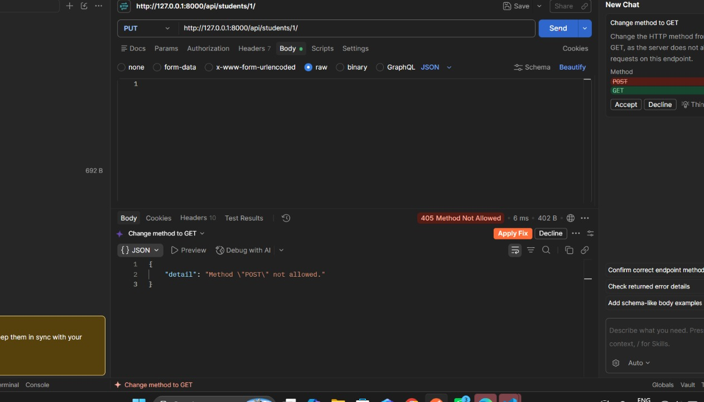
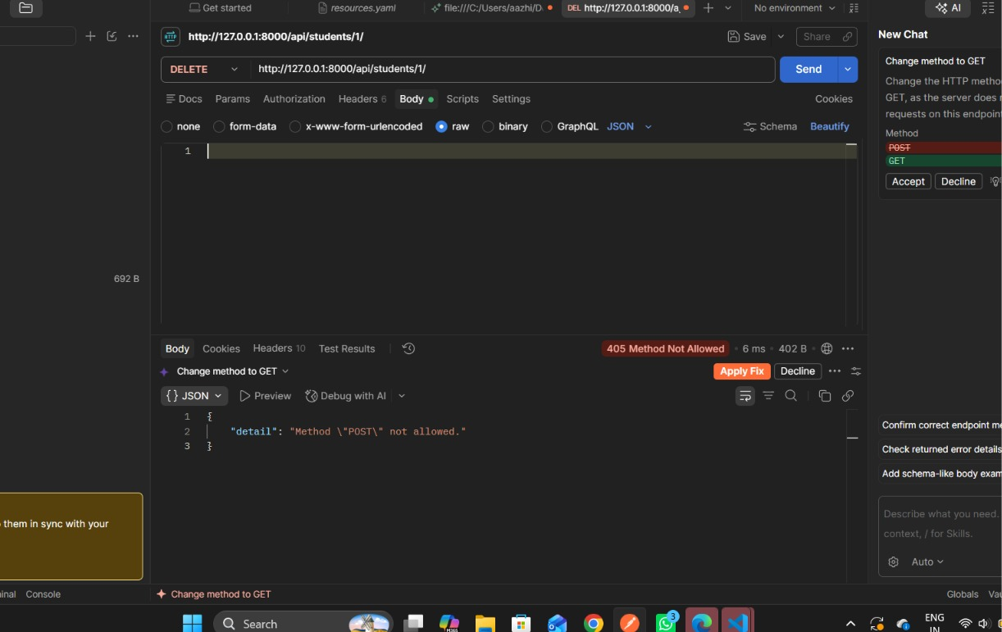

12.2 Additional Test Coverage per SOP
- Create tested with valid, missing, and duplicate-email data (cases 2 and 7).
- Read tested against both empty and populated tables (case 1).
- Update and Delete tested against valid and invalid record IDs (cases 4–6 and 8).
- Frontend responsiveness: the CSS layout uses a responsive grid intended to be checked at desktop and mobile widths.
- Backend-unavailable handling: verified via the frontend's try/catch fetch logic and API-status indicator described in Section 9.
Recommended before final submission: run each Postman request against a fresh migrated database, capture the response screenshots, and attach them to this report's Testing Results appendix together with the corresponding database state (e.g., via the Django admin or a SQLite browser).

13. Security and Quality Guidelines
Guideline | Status
No hard-coded passwords/API keys/DB credentials | SQLite requires no credentials; SECRET_KEY should be moved to an environment variable before production use
Environment variables for secrets/config | Recommended follow-up — see Future Enhancements
Input validation and sanitization | Implemented at model, serializer, and client level; output HTML-escaped in app.js
Parameterized ORM operations | All queries use the Django ORM (QuerySet filters), which parameterizes values automatically
Separation of frontend / backend / database responsibilities | Enforced via Django app structure (students app for data/API, templates/static for UI)
Meaningful naming | Model, serializer, view, and URL names follow Django/DRF conventions (Student, StudentSerializer, StudentListCreateView, etc.)

14. Version Control and Submission
- Initialize a Git repository at the project root (student_management_system/) if not already done, and commit in logical, incremental steps (project scaffold → model → serializer/views → URLs → frontend → Postman collection → README).
- Add a .gitignore excluding db.sqlite3, the virtual environment folder, and any __pycache__/ directories — the SOP requires that build artifacts and environments not be committed.
- Keep the existing README.md, which already documents installation, migration, running the server, and the full API reference.
- Push the final project to the approved Git/GitHub repository and record the link on the title page of this report.

15. UI and API Screenshots
This report was generated from the project source code; live screenshots could not be captured in this environment because it has no network access to install Django and its dependencies. Before submission, run the application locally (see README.md → steps 1–7) and insert screenshots for the following into this section:
- Home page with an empty student list.
- Home page with several student records and populated stat cards.
- Add Student form, including an inline validation error (e.g., an invalid phone number).
- Edit Student in progress (form pre-filled, "Cancel Edit" visible).
- Search and department-filter results.
- Django Admin list view for the Student model.
- A representative Postman request/response pair for each of the 8 collection requests.

16. Challenges and Solutions
Challenge | Solution Adopted
Preventing duplicate student records by email | Enforced uniqueness at the database level (unique=True) and surfaced the resulting integrity error as a clear serializer validation message rather than a raw 500 error
Searching across several text fields at once | Combined name/email/phone icontains lookups with OR filtering in get_queryset, then applied .distinct() to avoid duplicate rows when a query matches more than one field
Keeping validation consistent between browser and API | Mirrored the same rules (required fields, 10-digit phone, 0–10 CGPA) in both app.js and the DRF serializer so users get instant feedback while the API still rejects invalid data on its own
Reflecting server state in the UI after every change | Re-fetch and re-render the table and stat cards after every Create/Update/Delete instead of mutating the DOM optimistically, keeping the UI a reliable mirror of the database

17. Future Enhancements
- Add authentication/authorization (e.g., DRF token or JWT auth) so only logged-in staff can modify records, while read access can remain open or restricted as needed.
- Move SECRET_KEY, DEBUG, and database settings into environment variables (e.g., via django-environ) for safe production deployment.
- Add pagination to the list endpoint for large datasets, and server-side sorting on table columns.
- Introduce related entities such as Course and Enrollment to model many-to-many relationships between students and courses.
- Migrate the database to PostgreSQL or MySQL for production use, as suggested in the SOP's recommended stack.
- Add automated backend tests (Django's test framework / pytest-django) to complement the manual Postman suite.
- Optionally rebuild the frontend in React for a more component-driven UI, per the SOP's suggested architecture.

18. Conclusion
The Student Management System satisfies the core requirements of the SOP: a single well-defined entity with a validated database schema, a complete set of REST endpoints covering Create, Read, Update and Delete, server-side validation layered on top of client-side checks, a functional and responsive frontend integrated with the API via fetch, and a documented Postman suite for independent API verification. With the addition of authentication, environment-based configuration, and automated tests, the project would be ready for a production-grade deployment.

Appendix A: Dependencies
requirements.txt:
- Django>=5.0,<6.0
- djangorestframework>=3.15,<4.0

Appendix B: Example API Request
POST /api/students/
{ "name": "Arun Kumar", "email": "arun@example.com", "phone": "9876543210", "department": "Computer Science", "year": 3, "cgpa": 8.5 }

